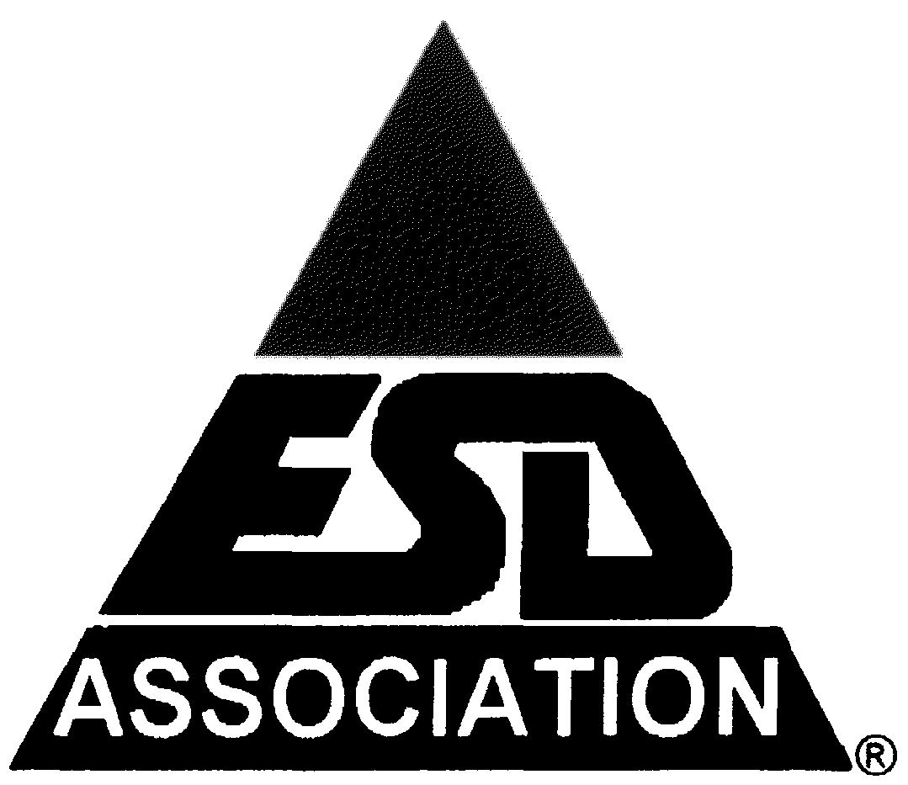**47th ANNUAL**

**ELECTRICAL OVERSTRESS/****ELECTROSTATIC DISCHARGE SYMPOSIUM**

**CALL FOR PAPERS**

**Including EOS/ESD Manufacturing Sessions**

***Why Riverside in September?***

The **47th Annual EOS/ESD Symposium** is strategically hosted in **Riverside, California**, a central hub for semiconductor and electronics innovation. This location allows attendees to connect with key ESD players in the industry, while also benefiting from an accessible and cost-effective venue for international participants.

***World-Class Exhibition and Learning Hub***

* **Industry-Leading Technical Sessions**: Gain firsthand insights from **global experts and researchers** presenting the latest advancements in ESD protection, manufacturing control, and system-level testing.
* **Practical Solutions for Real-World Challenges:** Learn directly from case studies, hands-on demonstrations, and industry-leading research.

***Non-Stop Networking Opportunities***

* **Global Networking Events:** Meet industry leaders from around the world during structured networking luncheons, receptions, and working groups.
* **Interactive Poster Sessions:** Engage with top researchers to discuss emerging trends and technologies in ESD mitigation.
* **Special Interest Panels:** Participate in expert-led discussions on the future of ESD-safe design and compliance standards.

***Shape the Future of EOS/ESD Solutions***

* **Exclusive Industry Roundtables:** Gain insights into upcoming industry trends, regulatory changes, and technological breakthroughs.
* **Meet Potential Partners and Clients:** Expand your professional network by interacting with suppliers, engineers, and business leaders shaping the future of ESD protection.

***Take the Next Step***

Secure your spot at the **47th Annual EOS/ESD Symposium** today!

Visit [**https://www.esda.org/events/47th-annual-eosesd-symposium-and-exhibits/**](https://www.esda.org/events/47th-annual-eosesd-symposium-and-exhibits/) for full details on registration and event schedules.