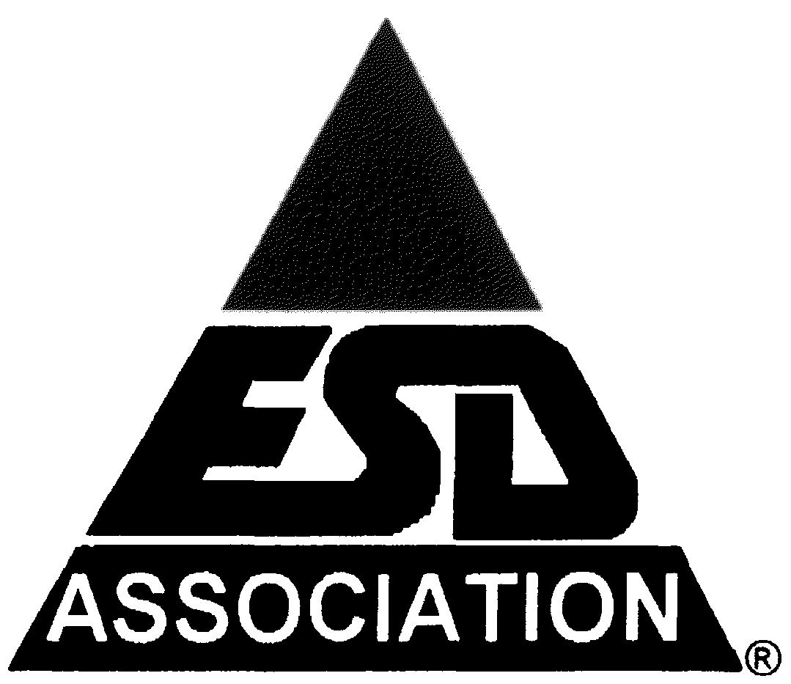**47th ANNUAL**

**ELECTRICAL OVERSTRESS/****ELECTROSTATIC DISCHARGE SYMPOSIUM**

**CALL FOR PAPERS**

**Including EOS/ESD Manufacturing Sessions**

### **Meeting Expenses and Cost-Saving Strategies**

|  |  |
| --- | --- |
| **Expense** | **Estimated Cost** |
| Symposium Registration | $XXX |
| Travel (Flights, Ground Transportation) | $XXX |
| Hotel Accommodations | $XXX/night |
| Meals & Incidentals | $XXX/day |
| Total Estimated Cost | $XXX |

**Cost-Saving Tips:**

* **Group Registration Discounts**: Save up to ***X%*** when registering more than ***X*** employees.
* **Early-Bird Pricing**: Reduced rates available for registrations before *[DATE]*.
* **Corporate Sponsorship & Expense Sharing**: Explore company reimbursement programs.

### **Return on Investment (ROI)**

* **Mitigate EOS/ESD Risks**: Implement new strategies to reduce costly failures.
* **Optimize Product Reliability**: Apply industry best practices for ESD-safe design.
* **Enhance Process Efficiency**: Gain insights into next-generation manufacturing techniques.
* **Expand Business Opportunities**: Connect with potential partners, suppliers, and clients.