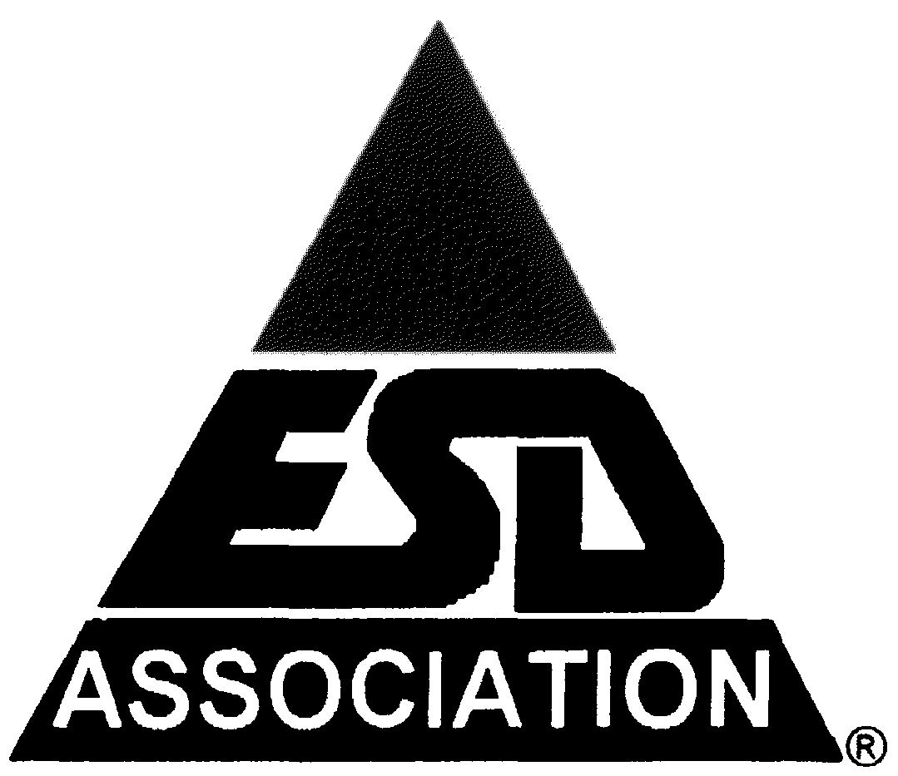**47th ANNUAL**

**ELECTRICAL OVERSTRESS/****ELECTROSTATIC DISCHARGE SYMPOSIUM**

**CALL FOR PAPERS**

**Including EOS/ESD Manufacturing Sessions**

*[DECISION MAKER’S FULL NAME AND TITLE]*  
Subj: Request for Approval to Attend the 47th Annual EOS/ESD Symposium

Dear *[DECISION MAKER’S FIRST NAME]*,

The **47th Annual EOS/ESD Symposium**, taking place **September 13-18, 2025, in Riverside, California**, is the leading global event dedicated to electrostatic discharge (ESD) and electrical overstress (EOS). As the *[SIGNIFICANCE OF YOUR POSITION WITHIN YOUR COMPANY]*, I am requesting approval to attend this premier symposium to gain industry-leading insights and bring back valuable knowledge that will directly benefit our company.

This event gathers **top researchers, industry experts, and technology leaders** to discuss the latest advances in **EOS/ESD protection, testing methodologies, failure analysis, and system-level solutions**. My participation will provide our team with **cutting-edge knowledge** in areas such as **emerging semiconductor technologies, ESD-safe manufacturing, and electrostatic control techniques**.

**Key Benefits of Attending:**

* **Access to exclusive technical sessions** covering state-of-the-art EOS/ESD challenges and solutions.
* **Opportunities to network** with industry professionals and potential business partners.
* **Hands-on learning and best practices** that can be implemented immediately upon return.
* **Workshops and technical training** tailored to real-world industry challenges.

With your approval, I would like to register early to take advantage of discounted rates. A detailed estimate of expenses is attached for your review.

Thank you for your time and consideration. I look forward to your approval.

Best regards,  
*[YOUR NAME AND JOB TITLE]*