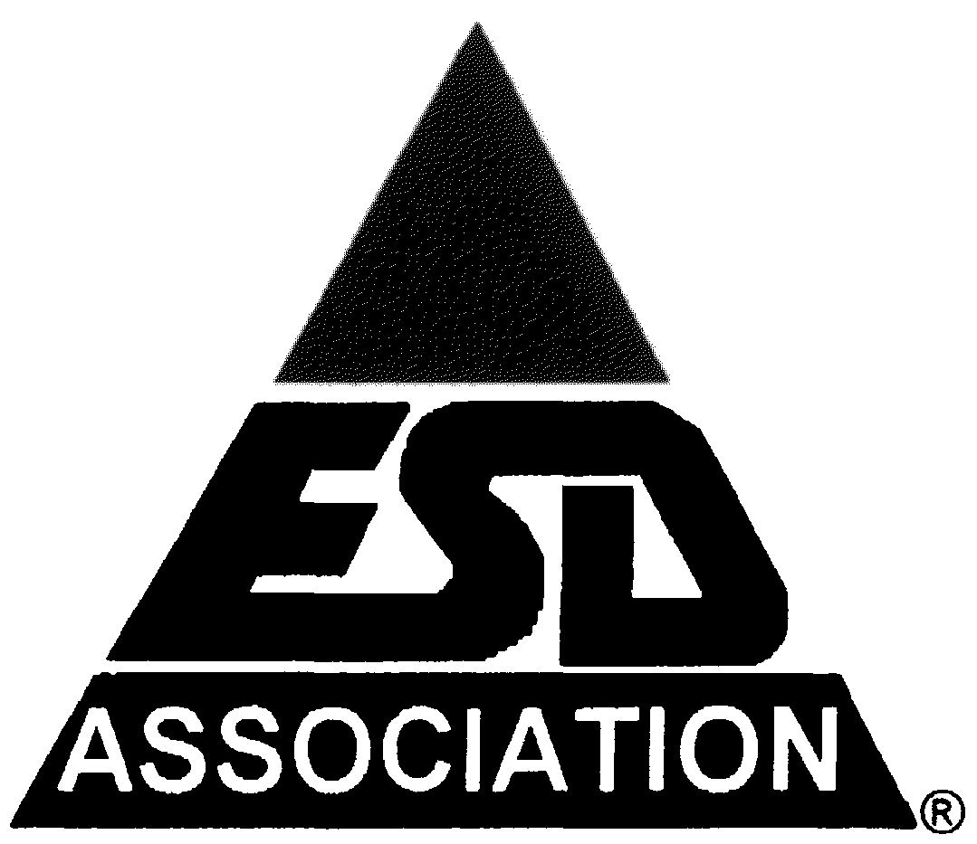**47th ANNUAL**

**ELECTRICAL OVERSTRESS/****ELECTROSTATIC DISCHARGE SYMPOSIUM**

**CALL FOR PAPERS**

**Including EOS/ESD Manufacturing Sessions**

***Maximize Your Company’s Return on Investment!***

The **47th Annual EOS/ESD Symposium**, held from **September 13-18, 2025, at the Riverside Convention Center in Riverside, CA**, is the premier event dedicated to addressing the challenges of electrostatic discharge (ESD) and electrical overstress (EOS). This symposium is designed to help professionals across the electronics, semiconductor, automotive, and industrial sectors mitigate EOS/ESD risks, improve product reliability, and stay ahead in a rapidly evolving industry.

***Why Should Your Company Invest in Your Attendance?***

**Industry-Leading Education and Training**

* Gain access to **cutting-edge research and solutions** in EOS/ESD mitigation strategies.
* Learn from world-renowned experts through **technical papers, tutorials, and workshops**.
* Enhance your team’s expertise in **ESD protection design, manufacturing control, and failure analysis**.

**Solutions for Every Challenge**

* Explore the latest advancements in **on-chip and system-level ESD protection**.
* Discover **novel EOS/ESD test methods, advanced modeling techniques, and process control strategies**.
* Learn best practices in **ESD-safe manufacturing and packaging** to reduce product failures.

**Define the Future of Your Business**

* **Emerging technologies** such as **3D integration, backside power design, and heterogeneous integration** are changing the landscape of semiconductor and electronics manufacturing - stay informed to remain competitive.
* Stay ahead of the curve with insights into **new industry standards, compliance requirements, and testing methodologies**.

**Expand Your Professional Network**

* Join a global community of **industry leaders, researchers, and technology innovators**.
* Participate in focused networking events, including **panel discussions, technical sessions, and working groups**.
* Collaborate with peers to solve industry challenges and shape the future of EOS/ESD protection.

**Investment and Cost-Saving Opportunities**

* **Group registration discounts** are available for companies sending multiple attendees.
* Early-bird rates provide substantial savings on registration fees.
* The knowledge gained from this symposium will help your company **reduce costly EOS/ESD failures, optimize product design, and enhance manufacturing efficiency**, delivering a strong return on investment.

***Take Action Now!!!***

Attending the **47th Annual EOS/ESD Symposium** is an investment in both your personal development and your company’s future success. Secure your spot today and bring back **innovative solutions, industry connections, and actionable insights** that will drive your organization forward.

For registration and more details, visit [**https://www.esda.org/events/47th-annual-eosesd-symposium-and-exhibits/**](https://www.esda.org/events/47th-annual-eosesd-symposium-and-exhibits/)